<https://www.youtube.com/watch?v=KlmaoQa_vEI&list=PL5nViEmyYI0bmfcM_s4P-dfzKrOpcFWWK&index=26>

<https://www.youtube.com/watch?v=YtZLIsqWo-0&list=PL5nViEmyYI0bmfcM_s4P-dfzKrOpcFWWK&index=27>

https://tech.osteel.me/posts/from-vagrant-to-docker-how-to-use-docker-for-local-web-development

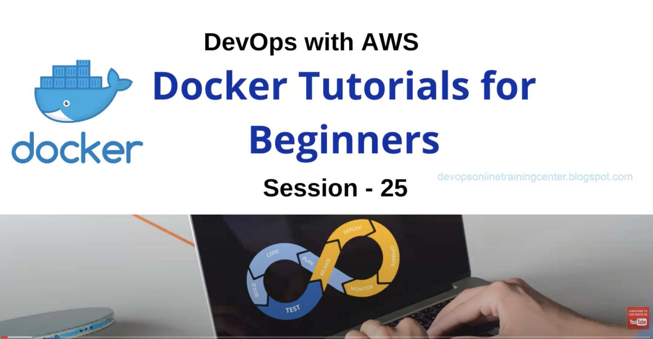

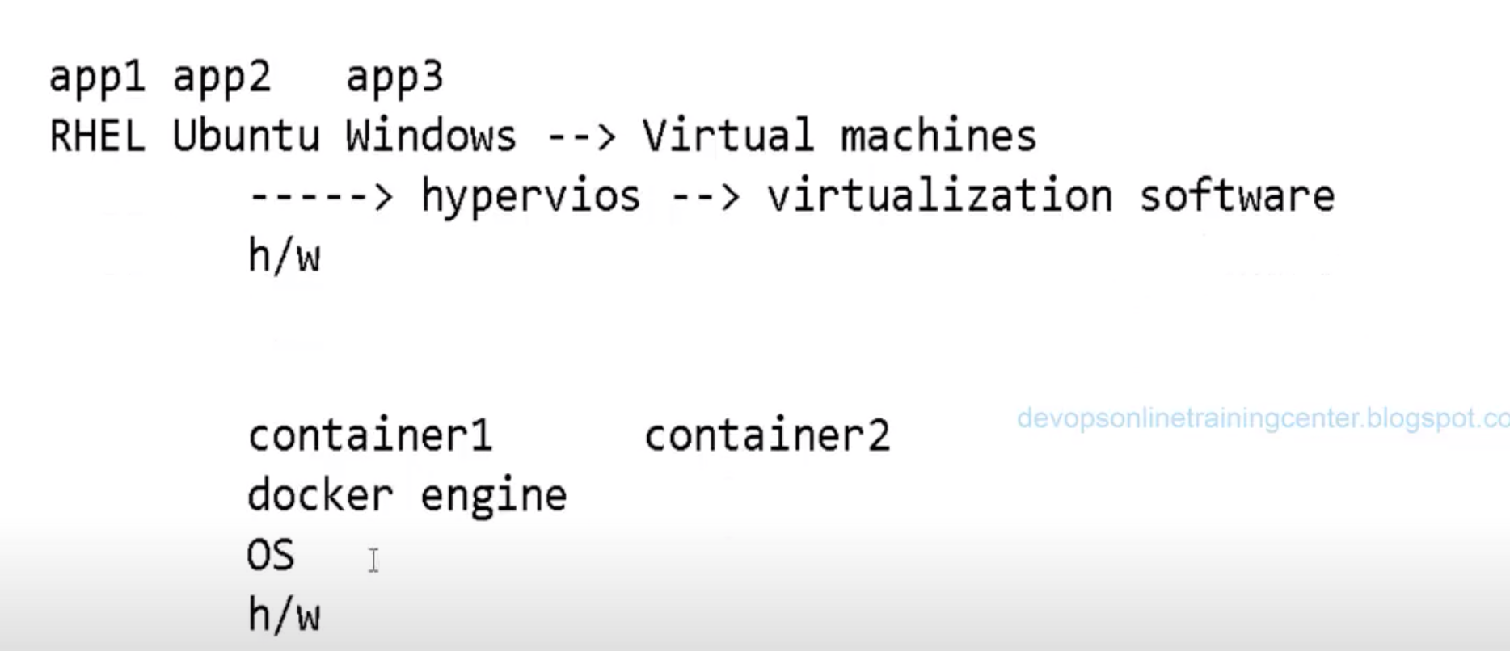

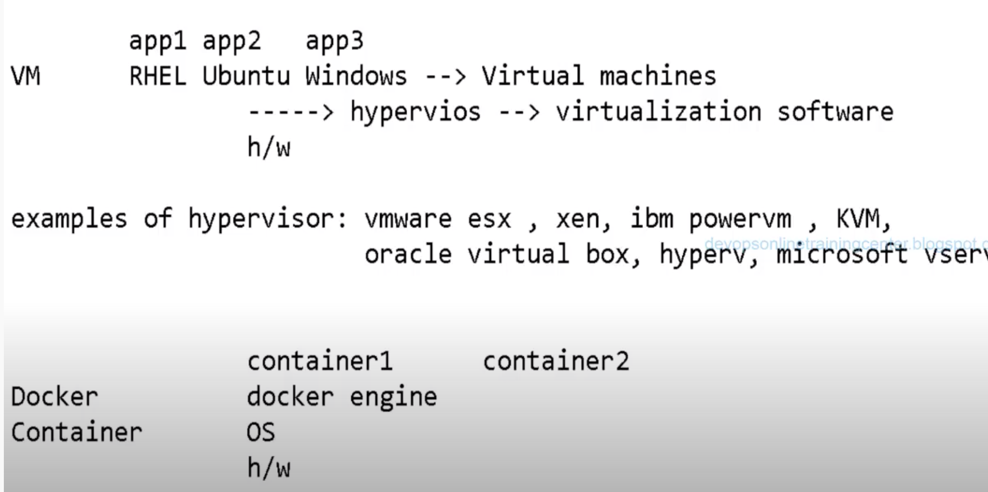

$apt install docker

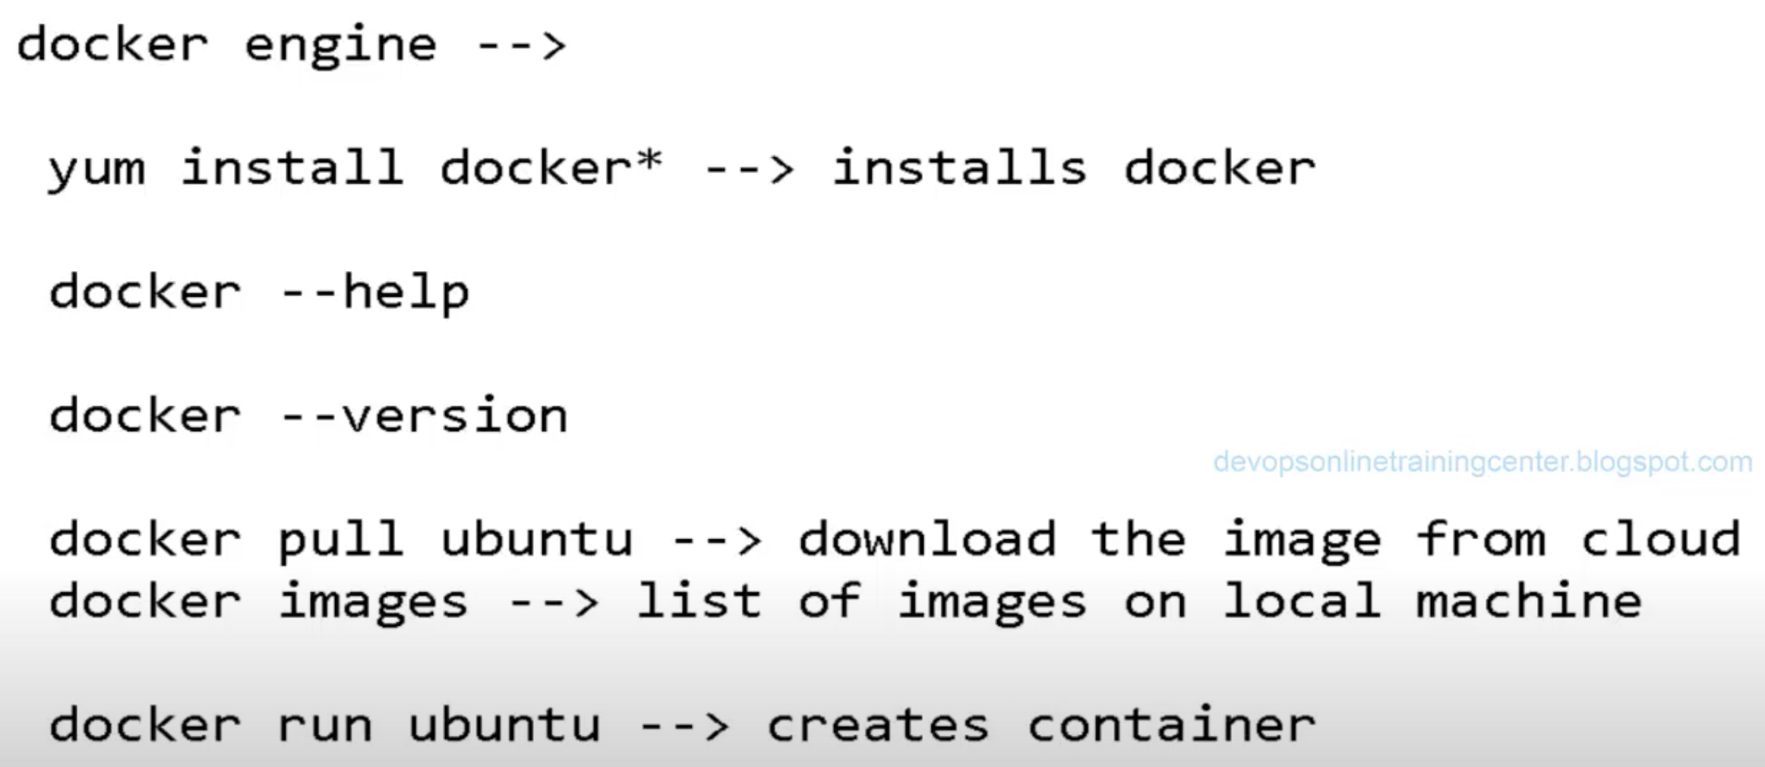

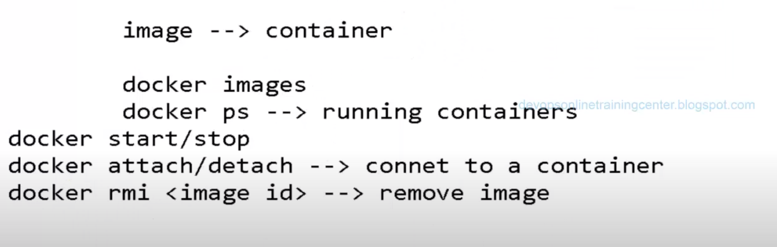

For Centos system:

Use command: $docker pull centos

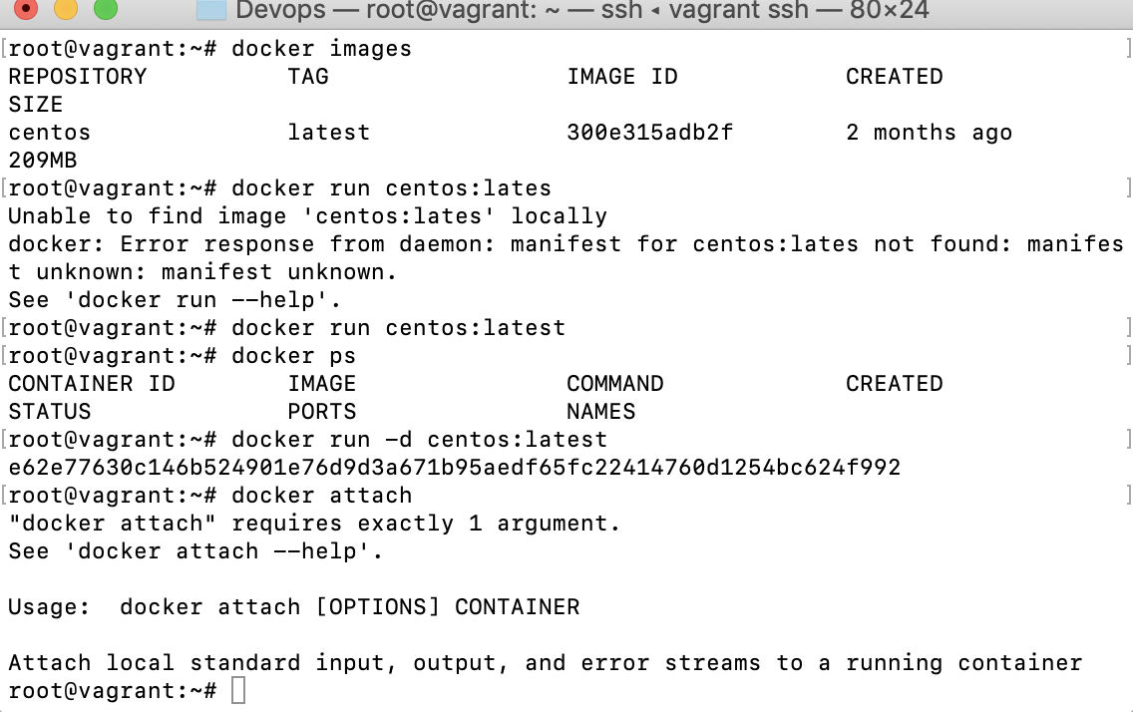

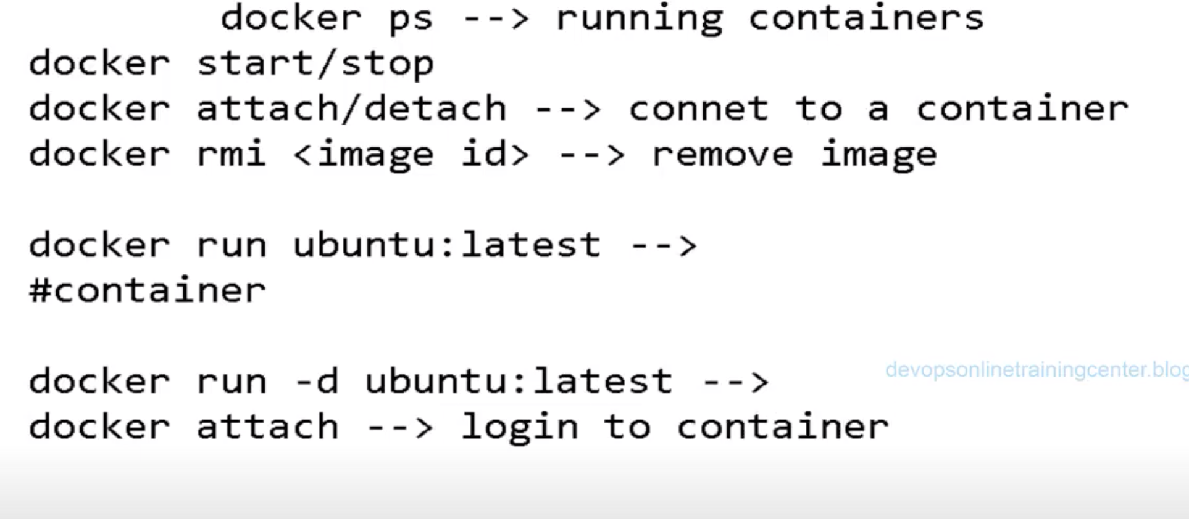

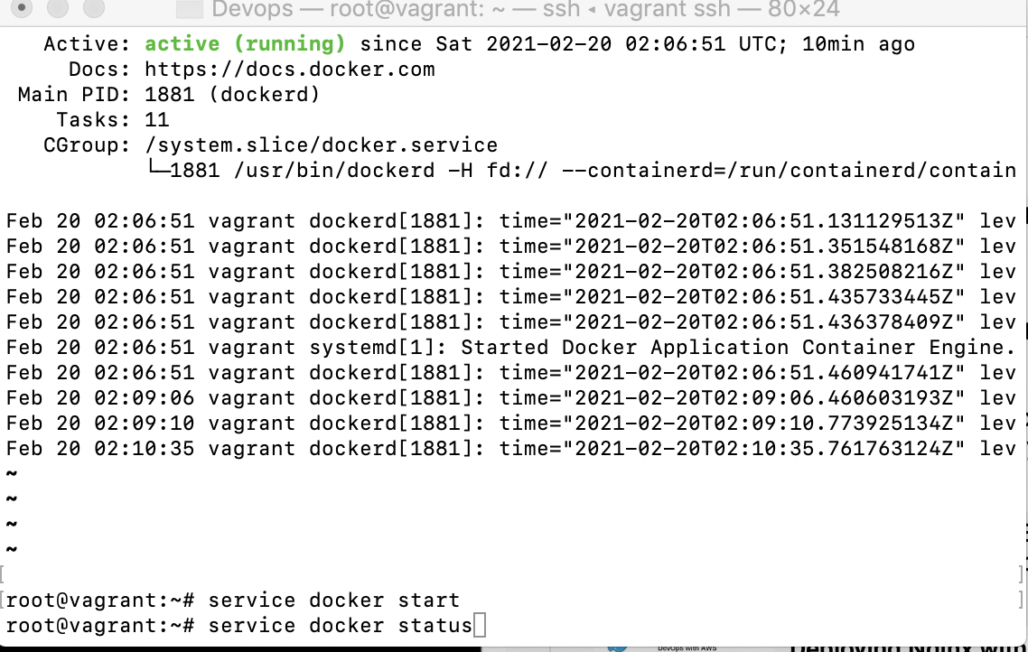

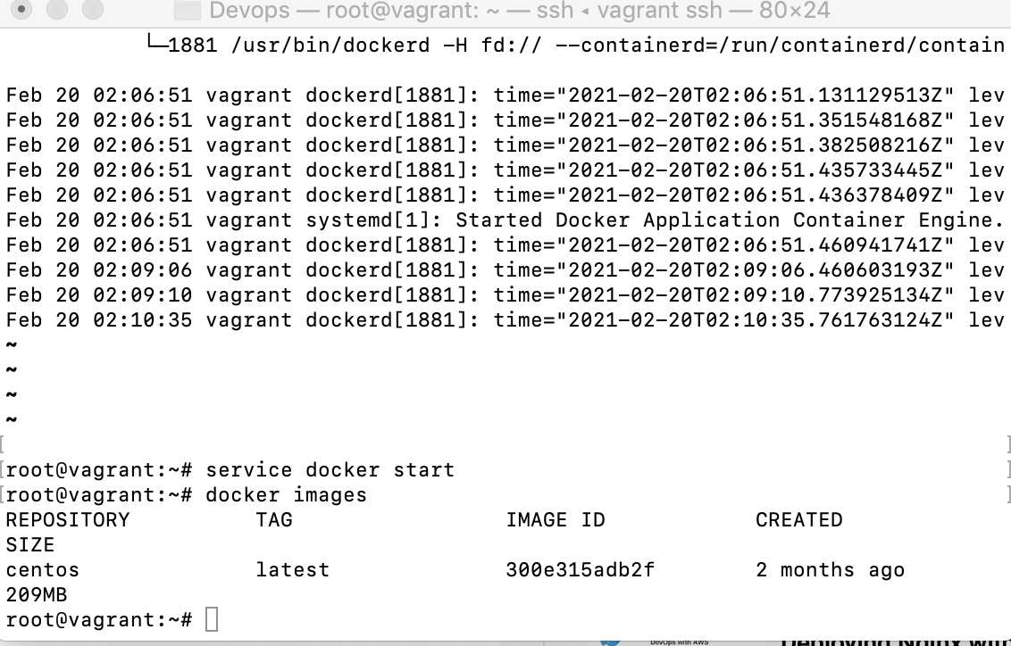

Attached shell to docker:$docker run centos:latest /bin/bash

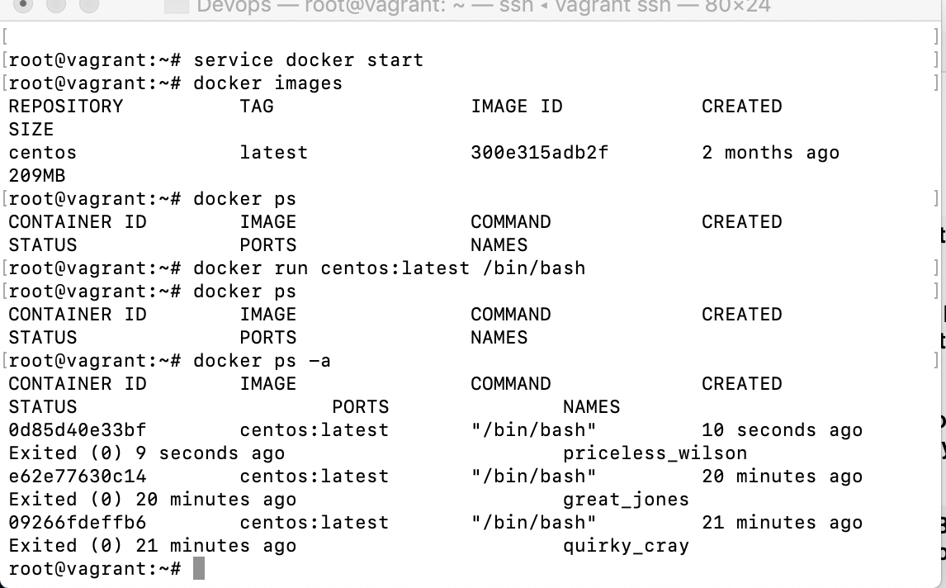

To execute the docker in machine and it’s switch to the docker container

[root@vagrant]$docker run -t -i centos:latest

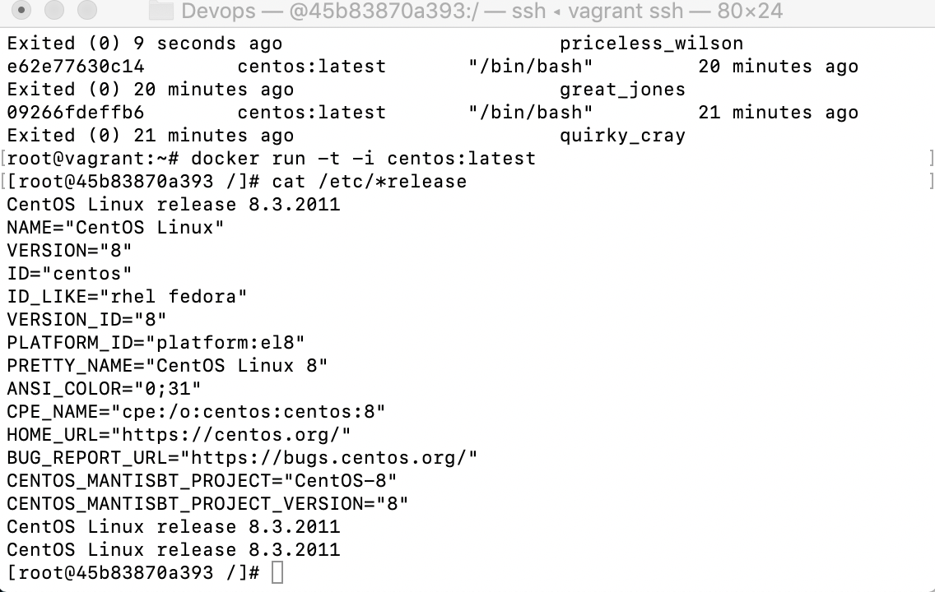

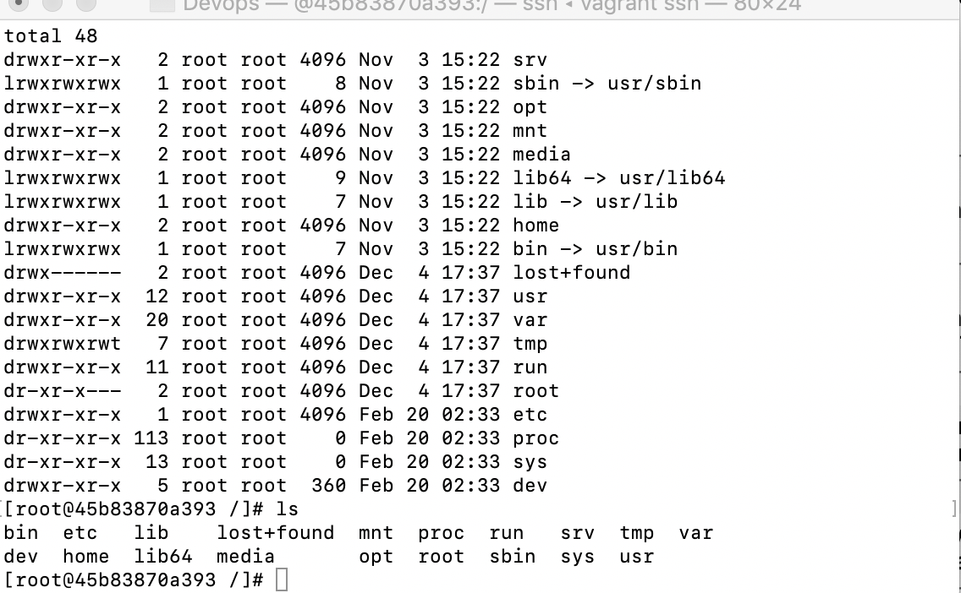

Pull docker image:

It contains only basic commands, other commands we need to install on it.

Create container:

Customize/adding app:

Then create image and share with client or machine where we need to work.

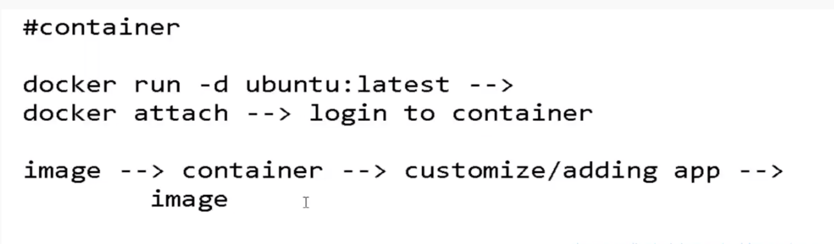

Install all other app/command, first we will need to run command #apt-get update🡪Ubuntu

$yum update-🡪Centos

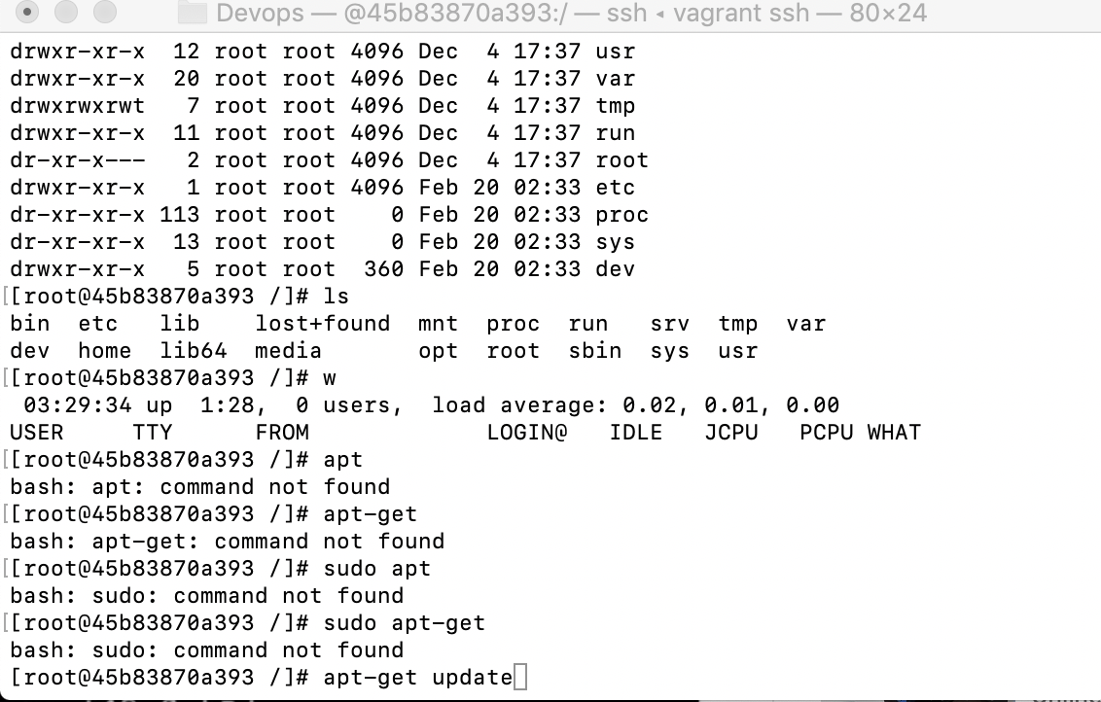

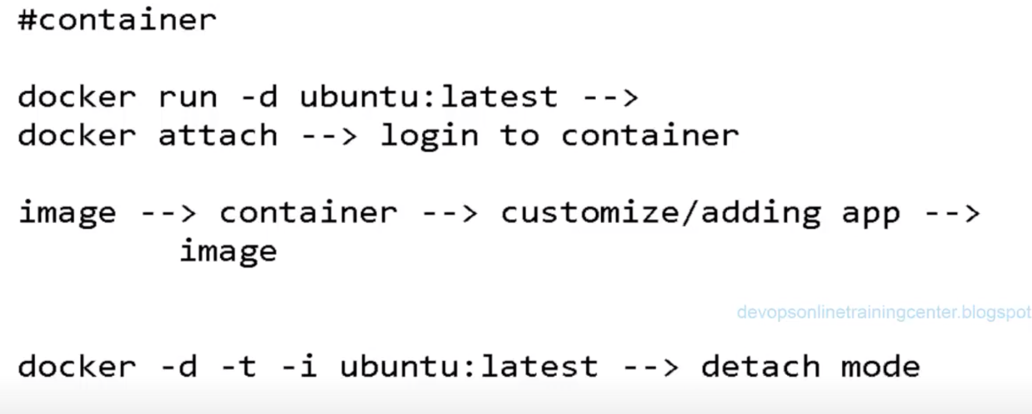

$docker run -d -t -i ubuntu:latest Or used

$docker run -t -i ubuntu:latest Or Used

$docker run -d -t ubuntu:latest /bin/bash

Use yum update once switch to docker container and install the updates in container–[root@a6214fbeaf6e/]# yum update

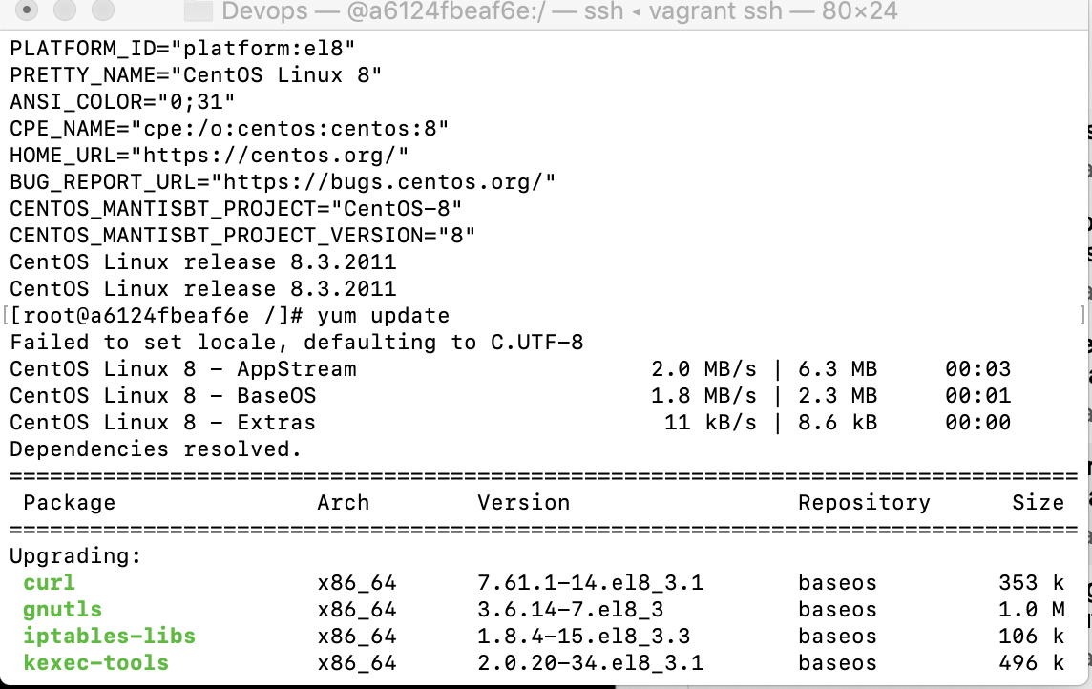

Installing is basically the same, you do '**yum install** package' or '**apt**-**get install** package' you **get** the same result. **Yum** automatically refreshes the list of packages, whilst with **apt**-**get** you must execute a command '**apt**-**get** update' to **get** the fresh packages.

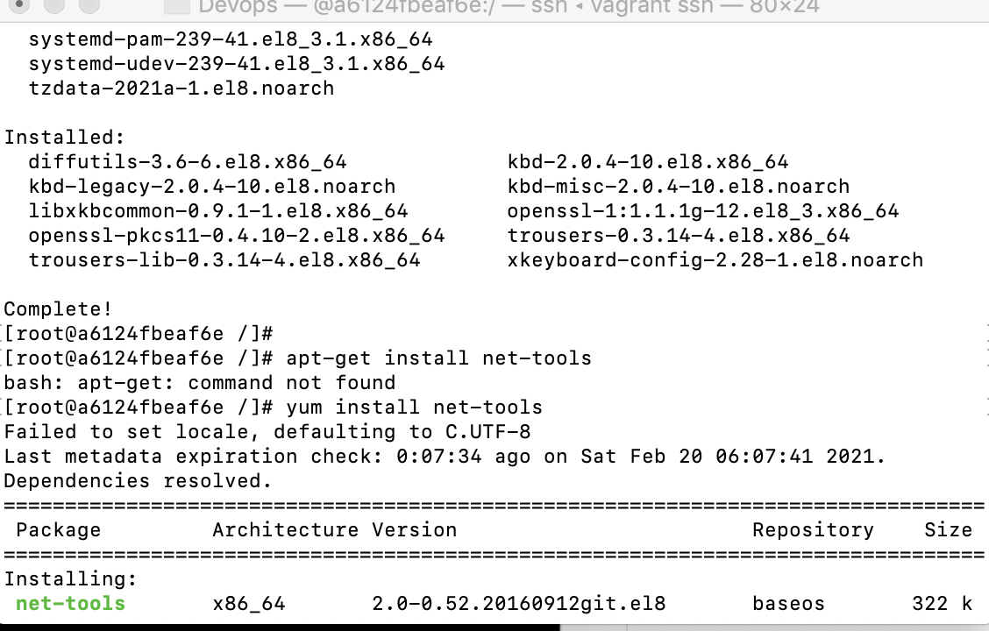

After Installing the net-tools, we are able to see ipaddress of container:

[root@a6124fbbeaf6e /]ifconfig

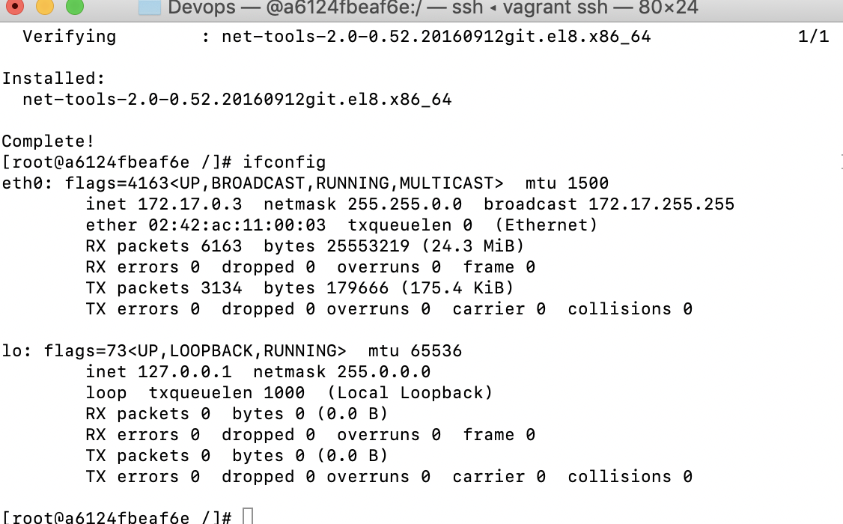

Exit from the container and switch to root.

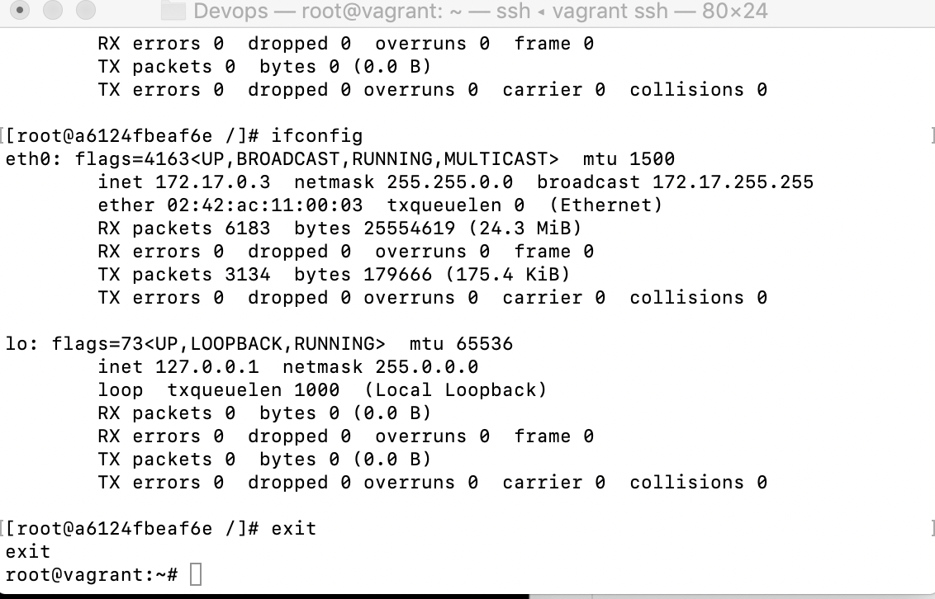

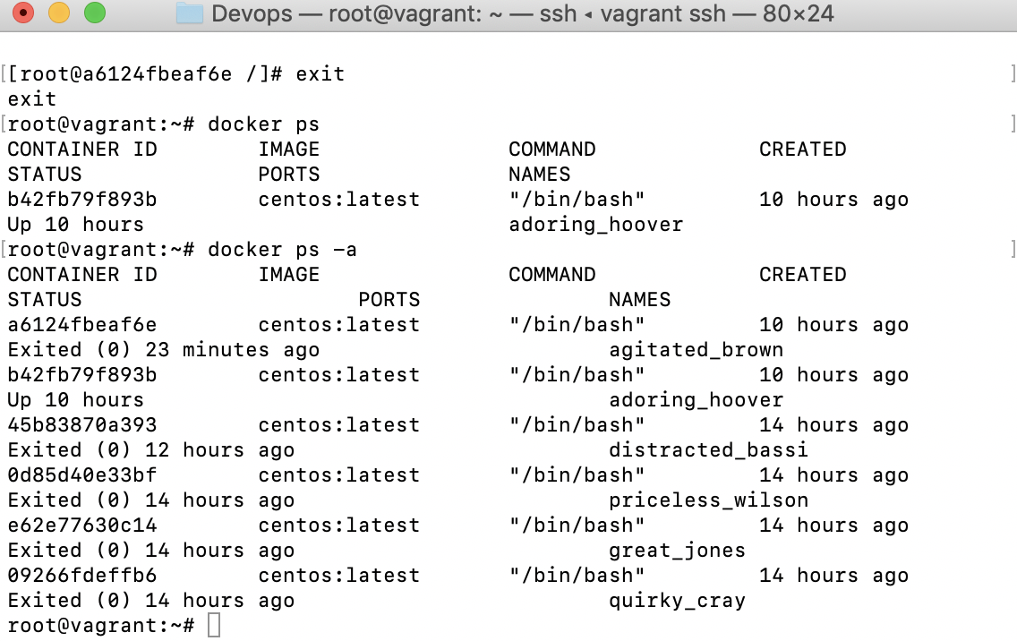

Docker Initialization steps:

1. Install docker
2. Start the docker service.

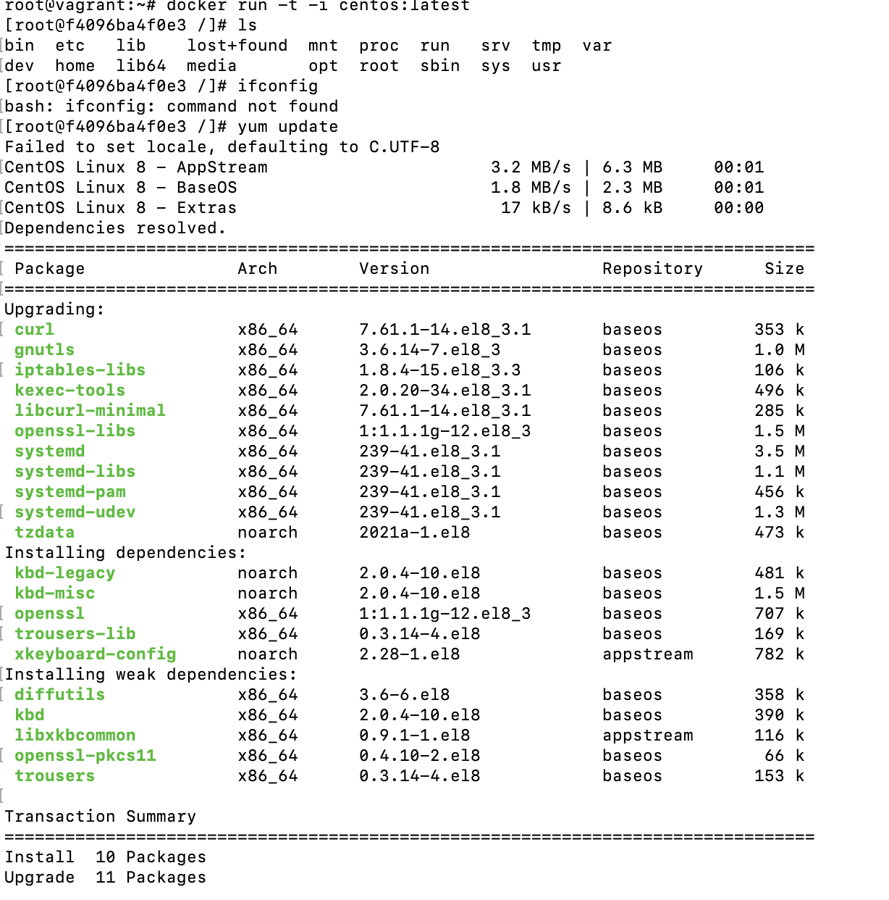

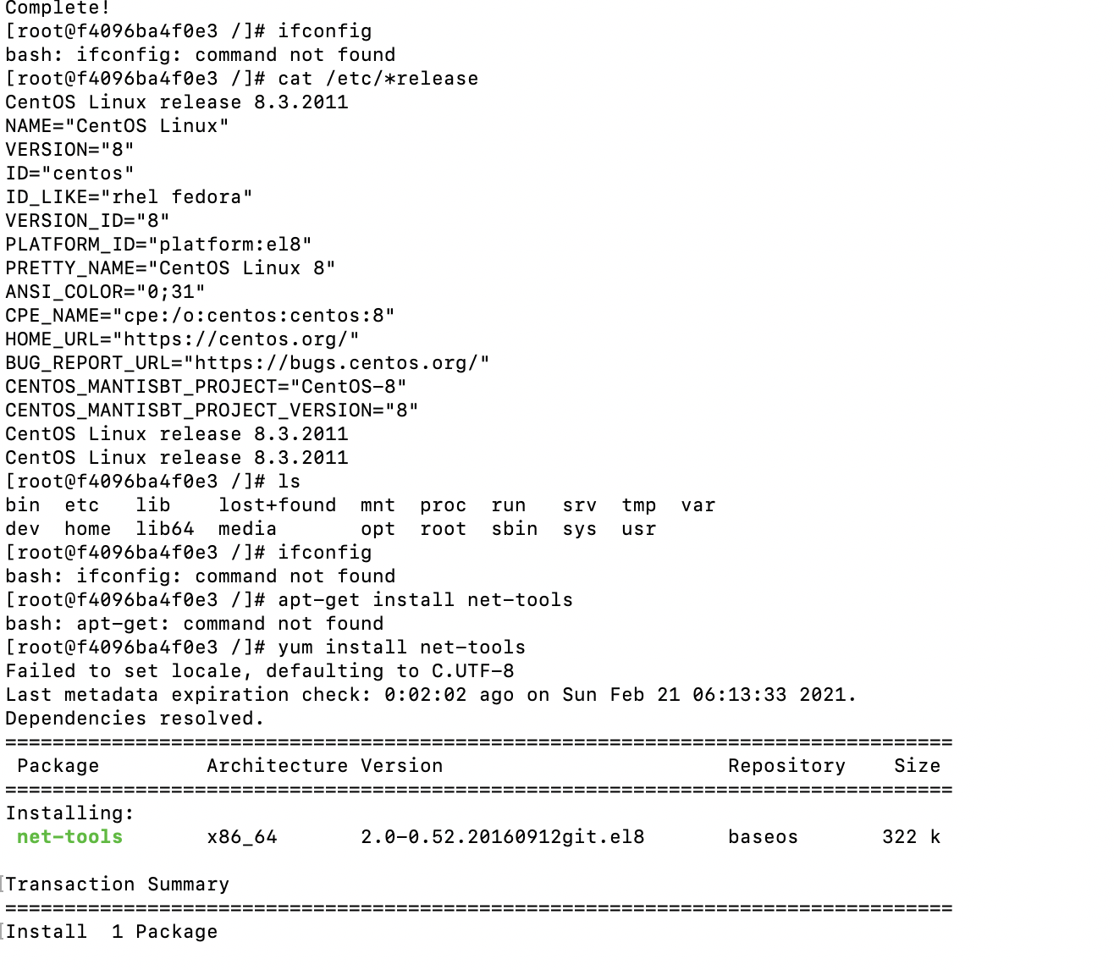

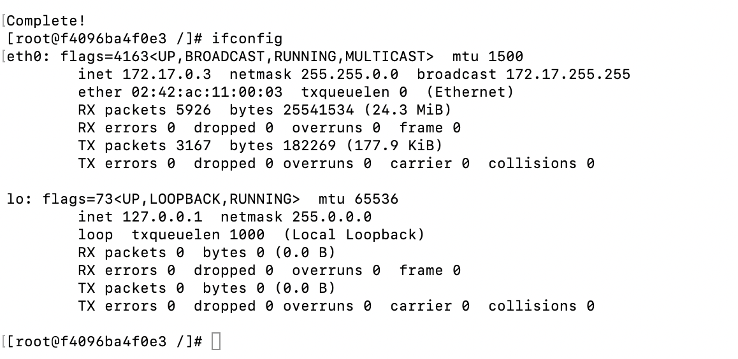

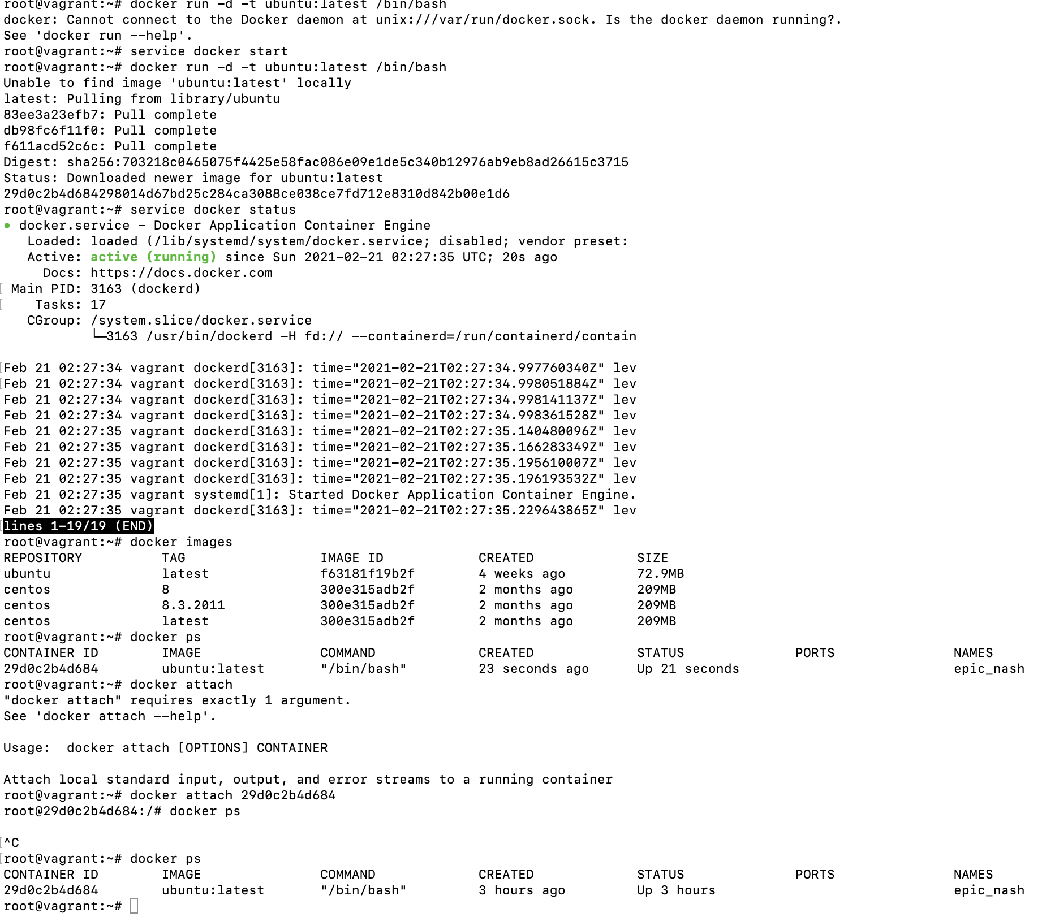

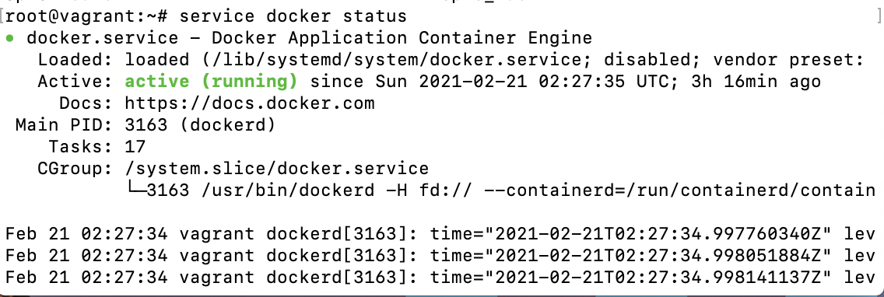

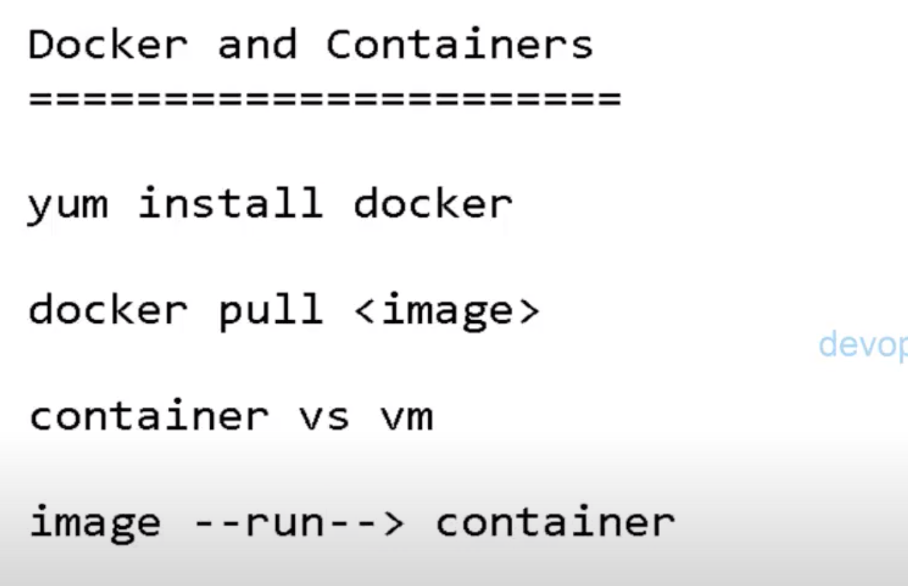

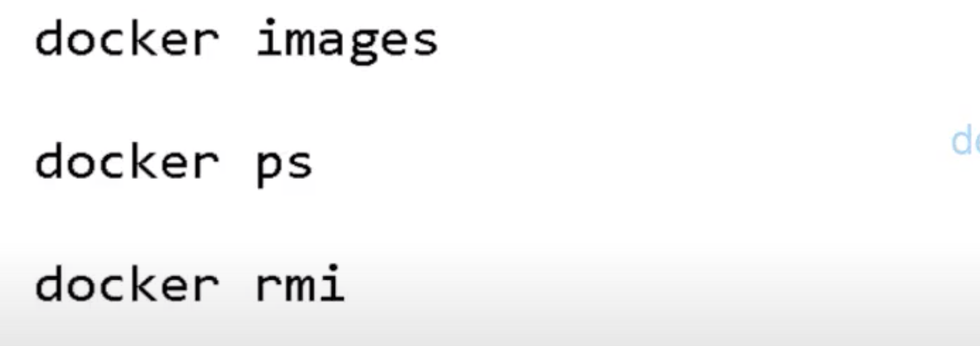

Docker images-🡪 list the images name

Docker ps 🡪 list the container name

Docker rmi <imageID>🡪 remove the image

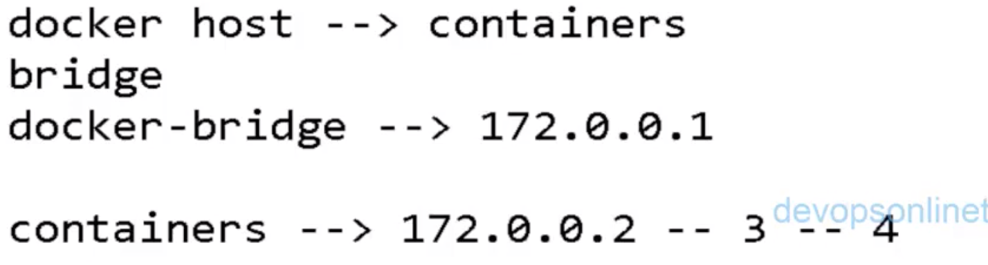

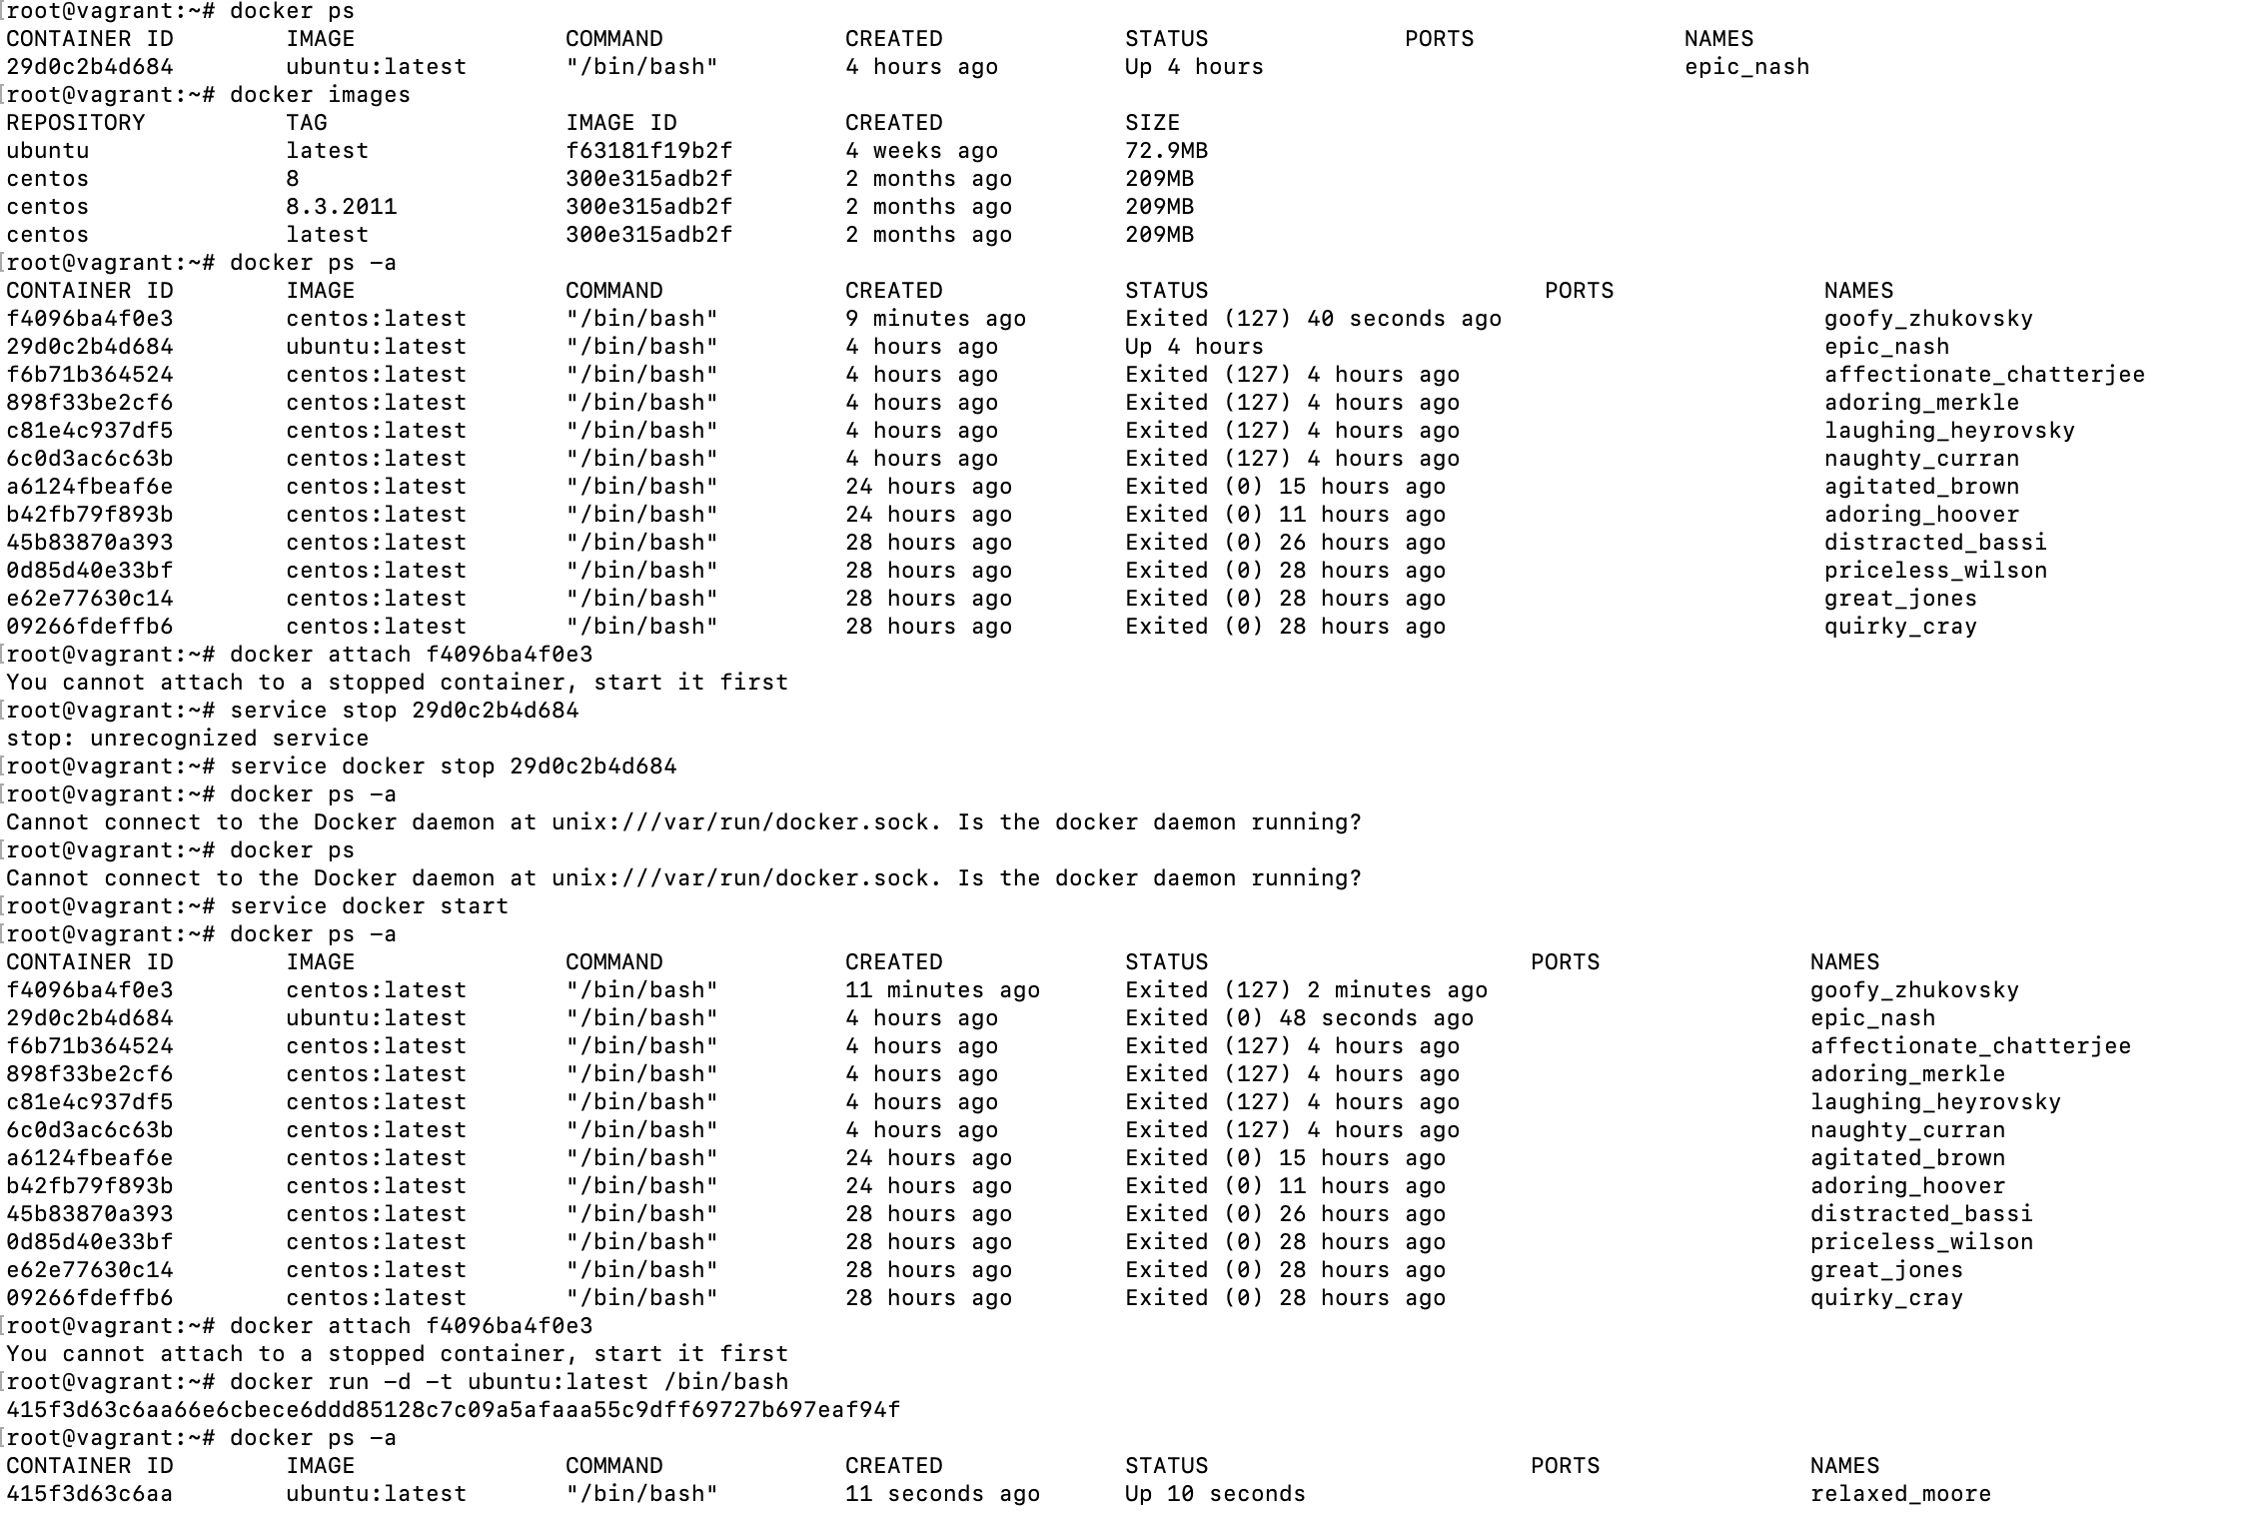

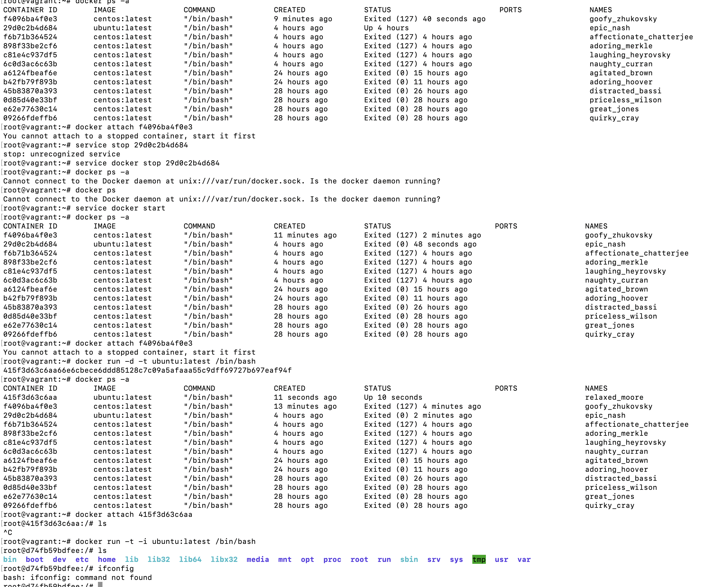

#docker run -i -t -d centos:latest 🡪 it will create docker in deattached mode.

If we exit it then

We connection will not lost with docker container.

#docker run -i -t centos:latest 🡪 it will create docker in attached mode.If we exit it then

We lost the connection with docker container.

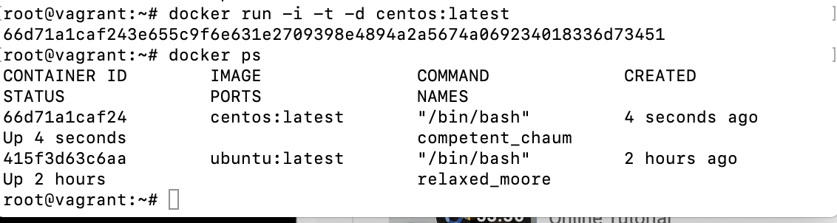

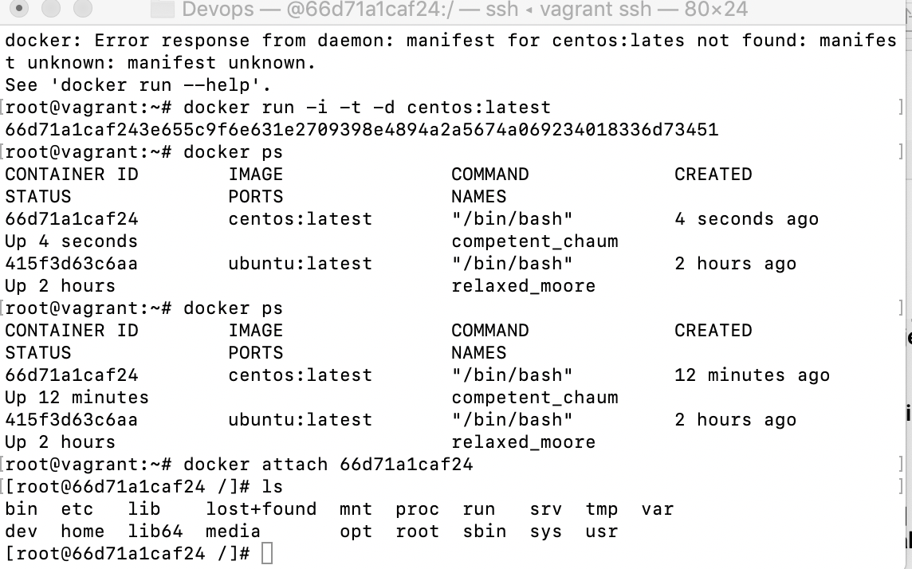

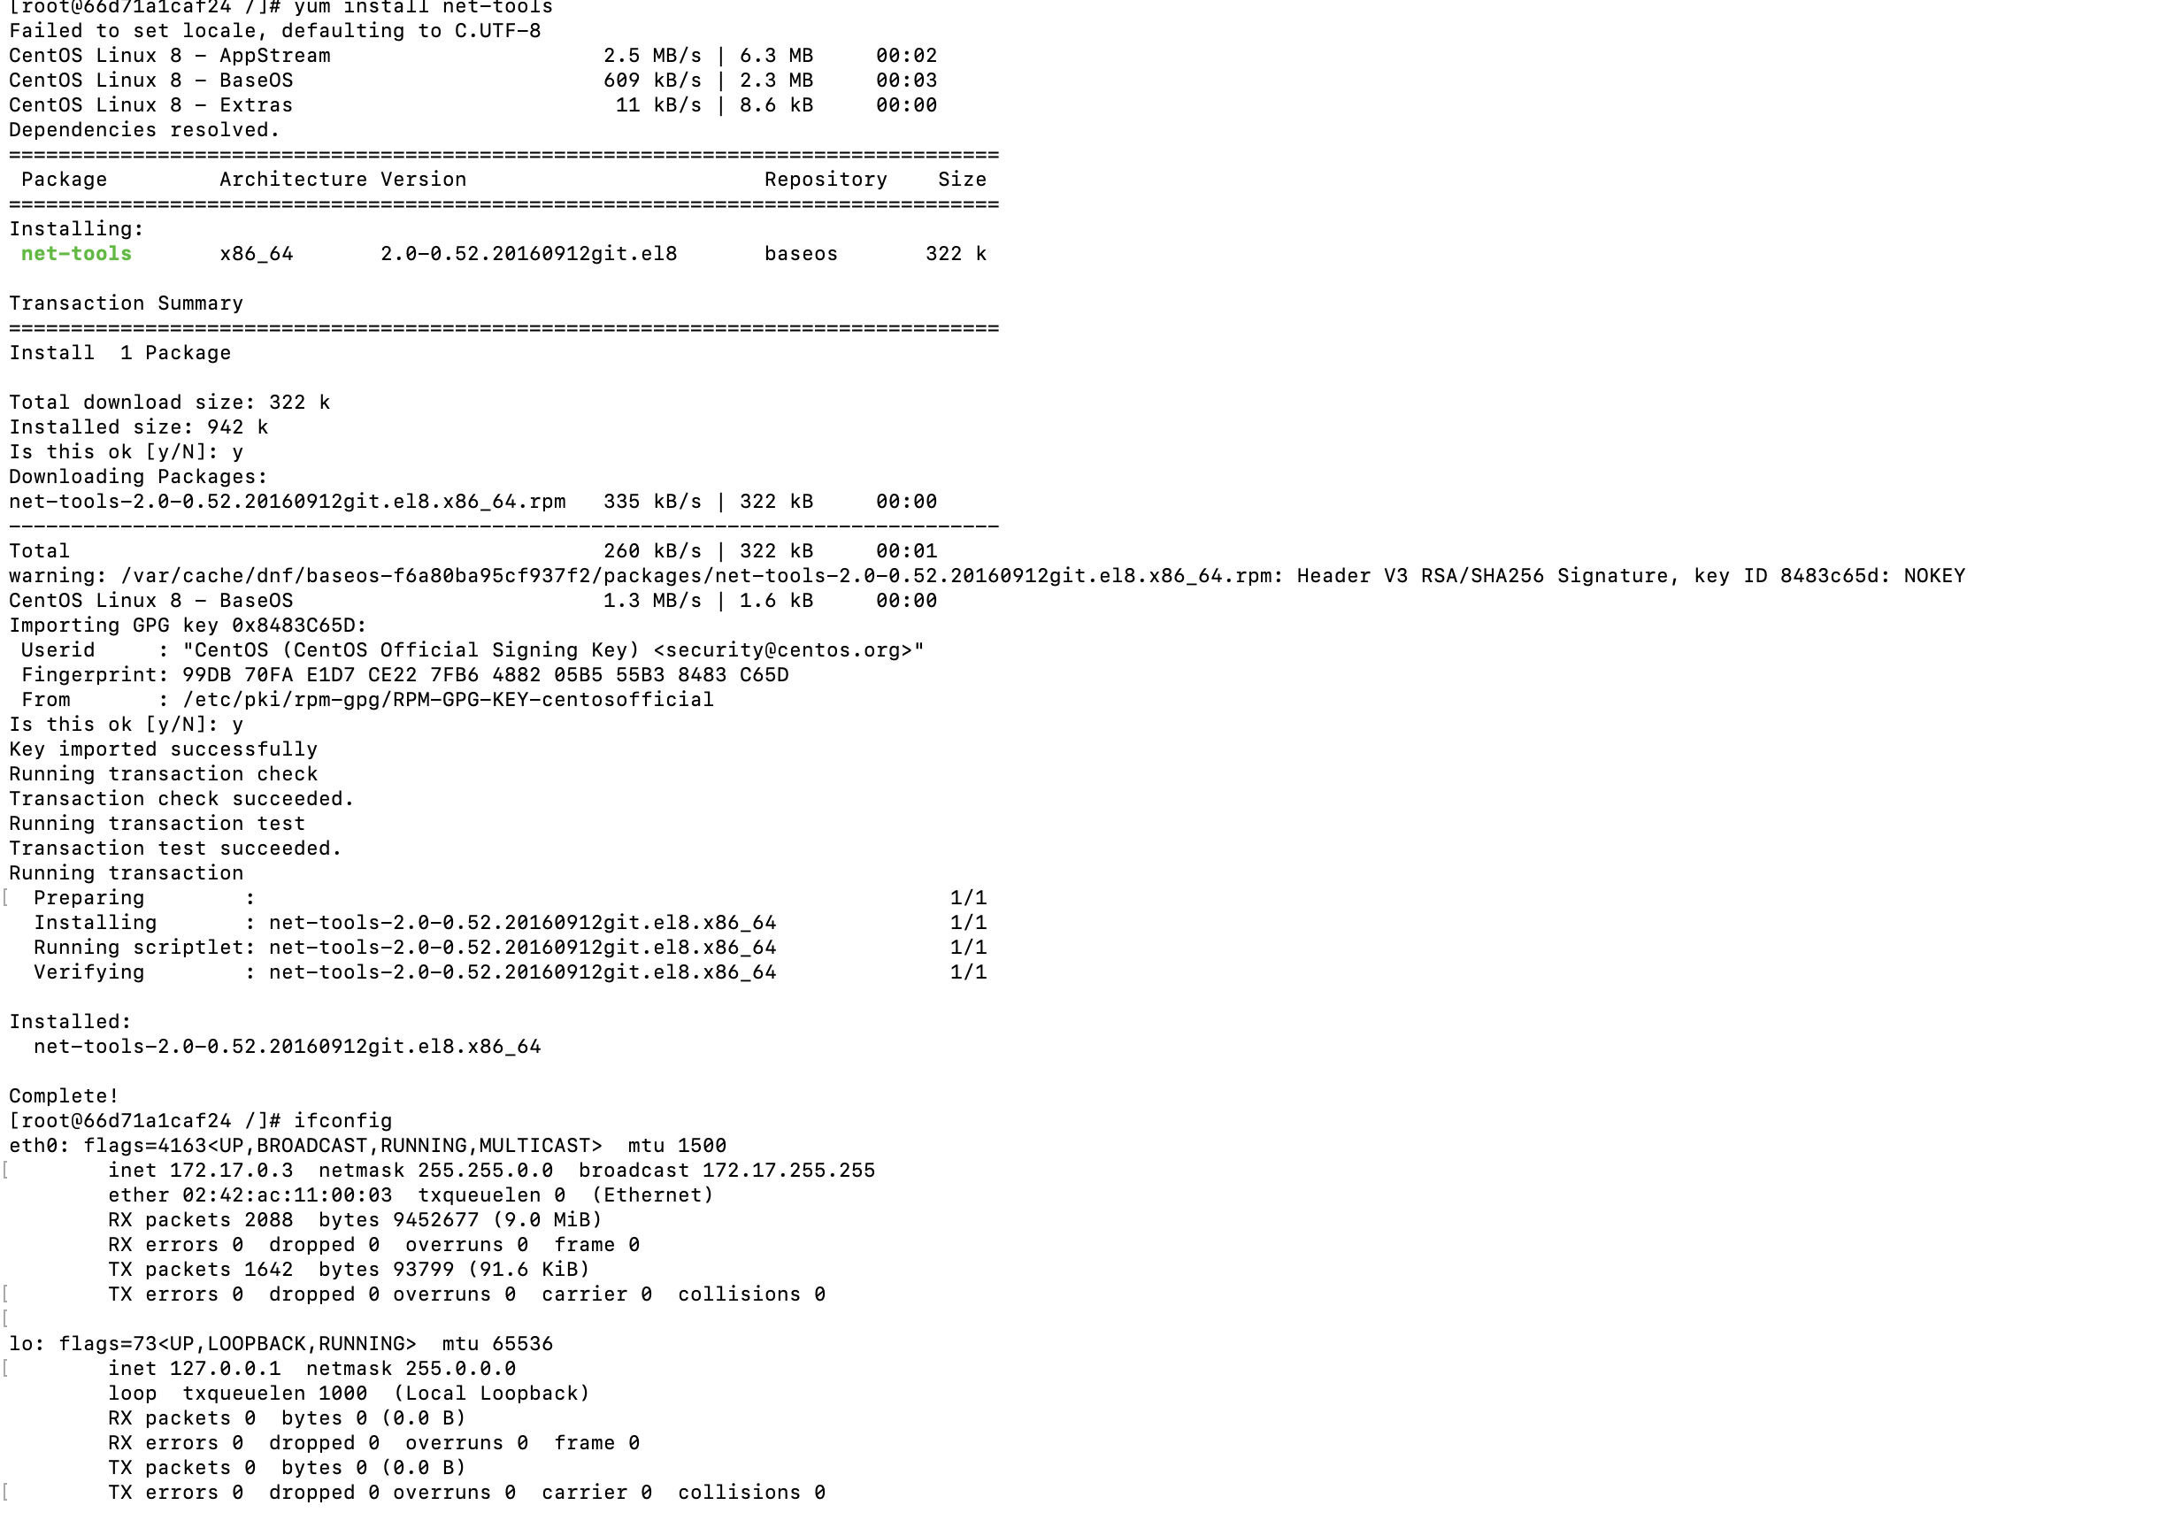

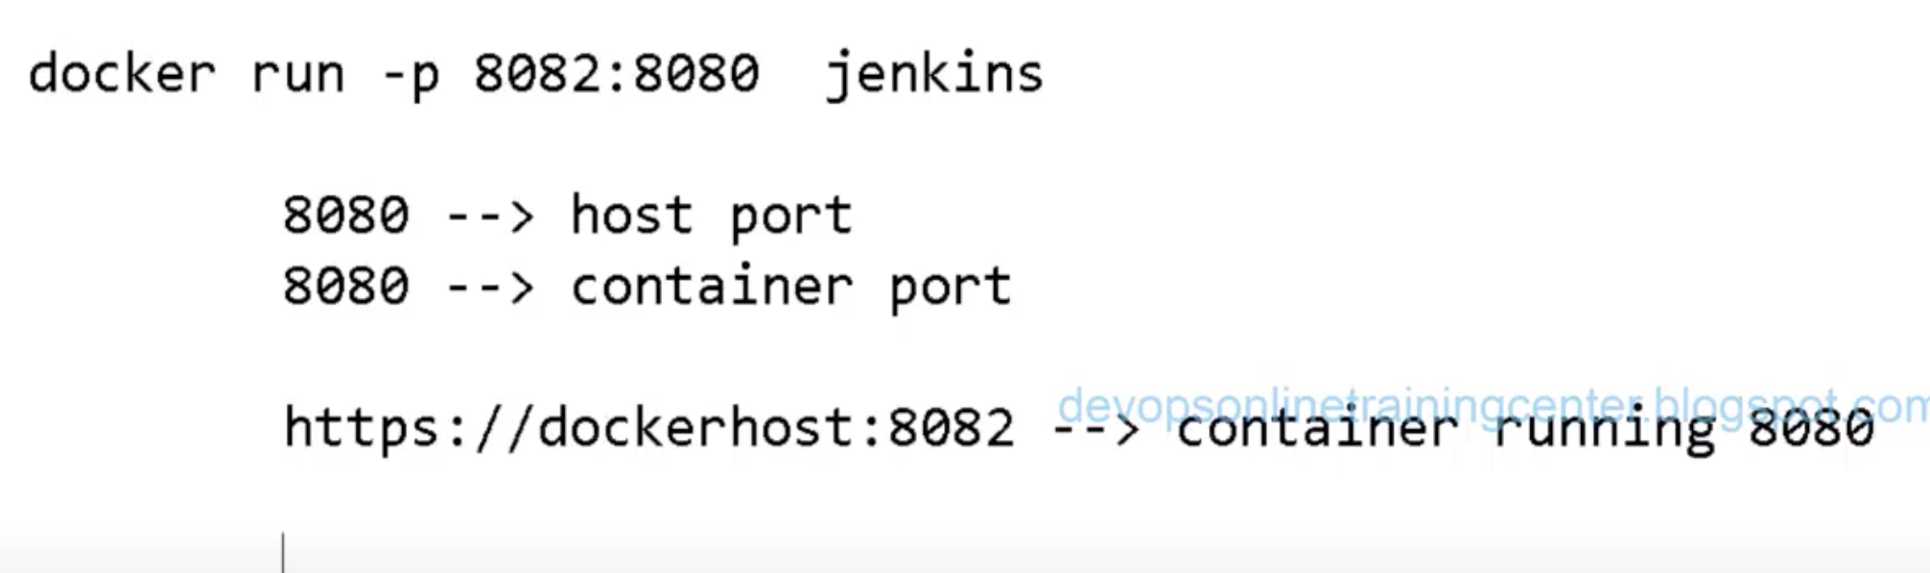

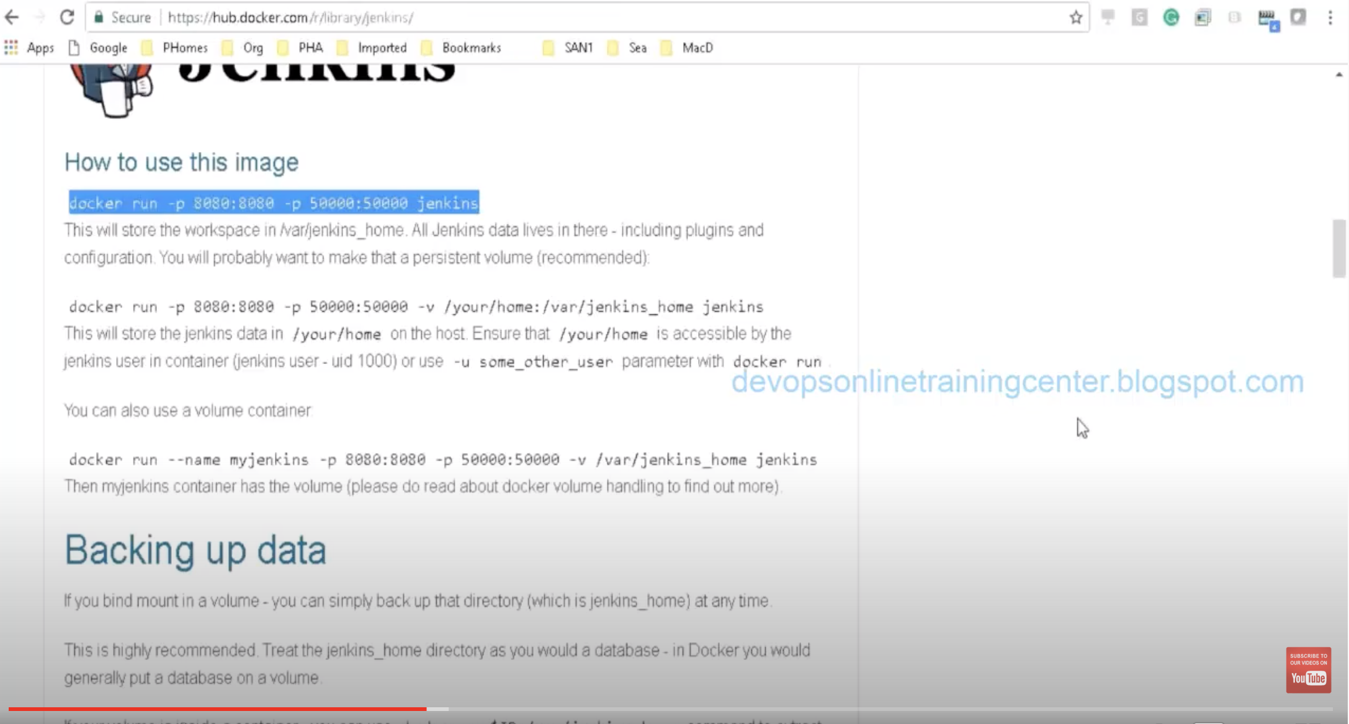

<https://github.com/jenkinsci/docker/blob/master/README.md>

<https://github.com/jenkinsci/docker/blob/master/README.md>

docker run -p 8080:8080 -p 50000:50000 jenkins/jenkins:lts

root@vagrant:~# docker run -i -t -p 8082:8080 jenkins/jenkins:lts

Jenkins pwd:

1fd16b0e0fc644f4ae23df6c8b855ddd

3b50f6d504034abba6c02bb19fb20f6d

<http://192.168.33.10:8082/login?from=%2F-->> Once the Jenkins is up and running use the host Ip address to open the Jenkins

Now Jenkins jobs is running on container.

Create a job in Jenkins and see the id,pwd,uname -na,hostname

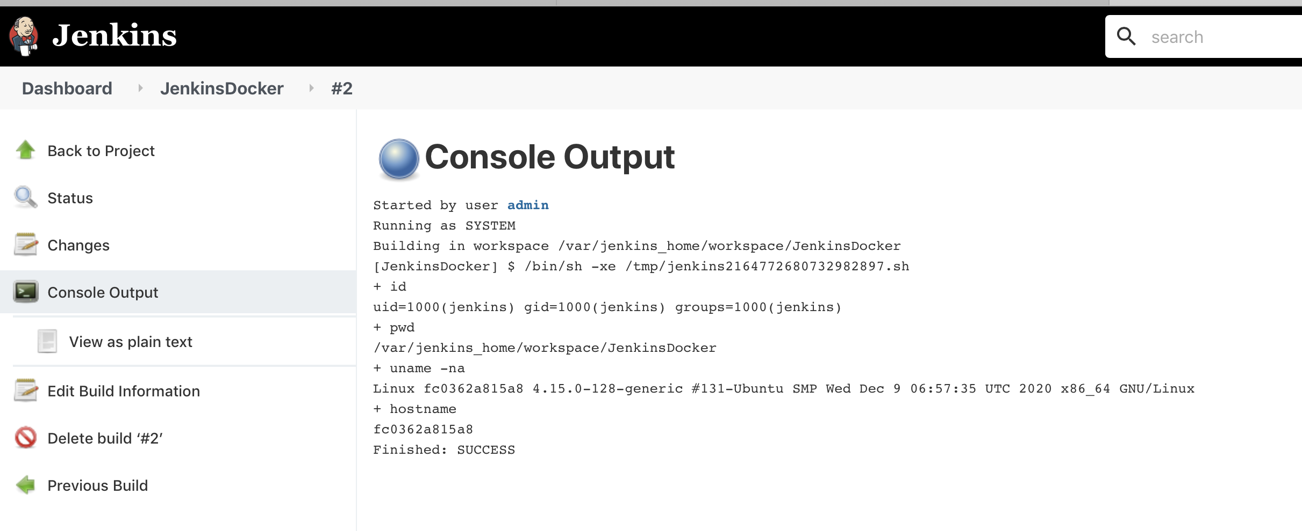

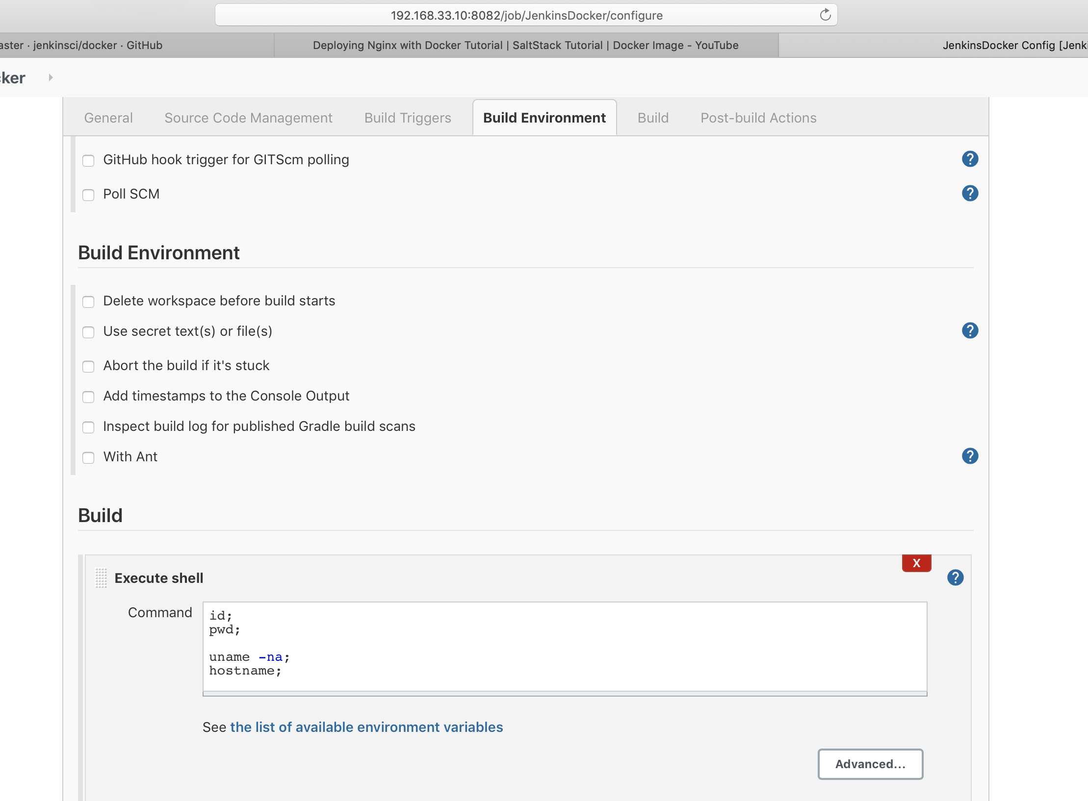

On agent machine we can ssh to master and see the docker is up and running for master

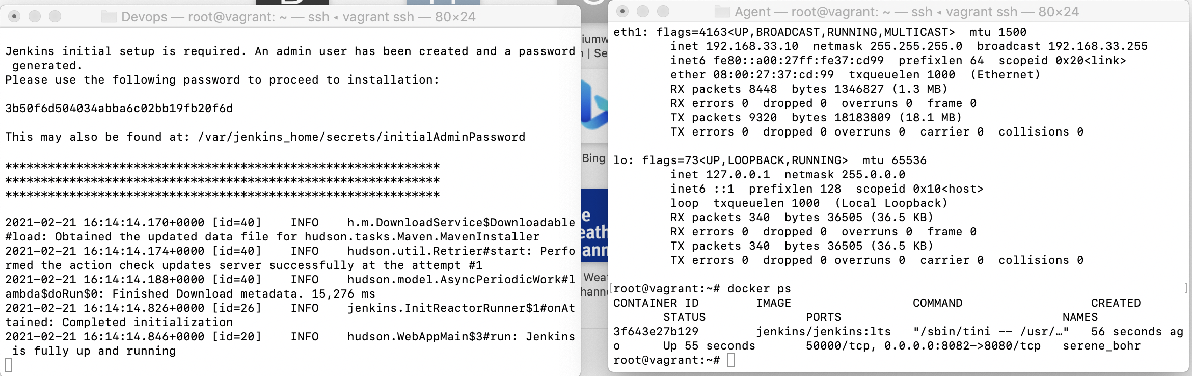

Hostname is same as docker container id- showing on agent machine after doing ssh of master on agent machine.

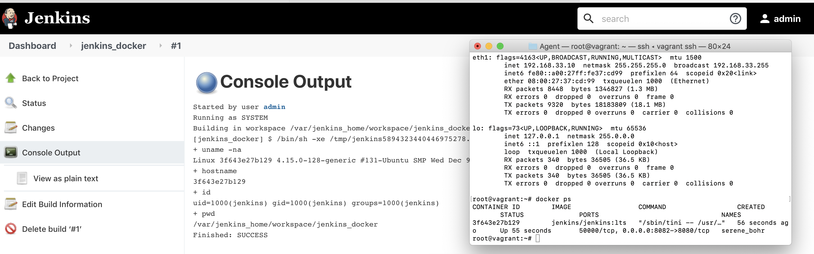

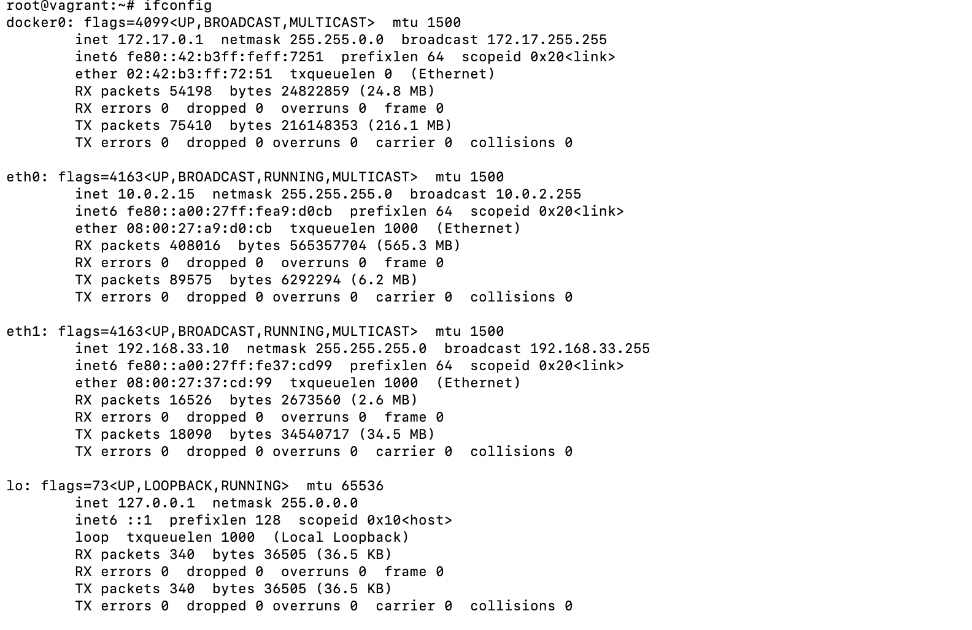

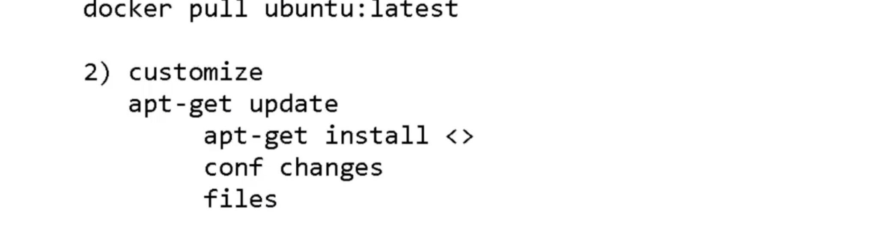

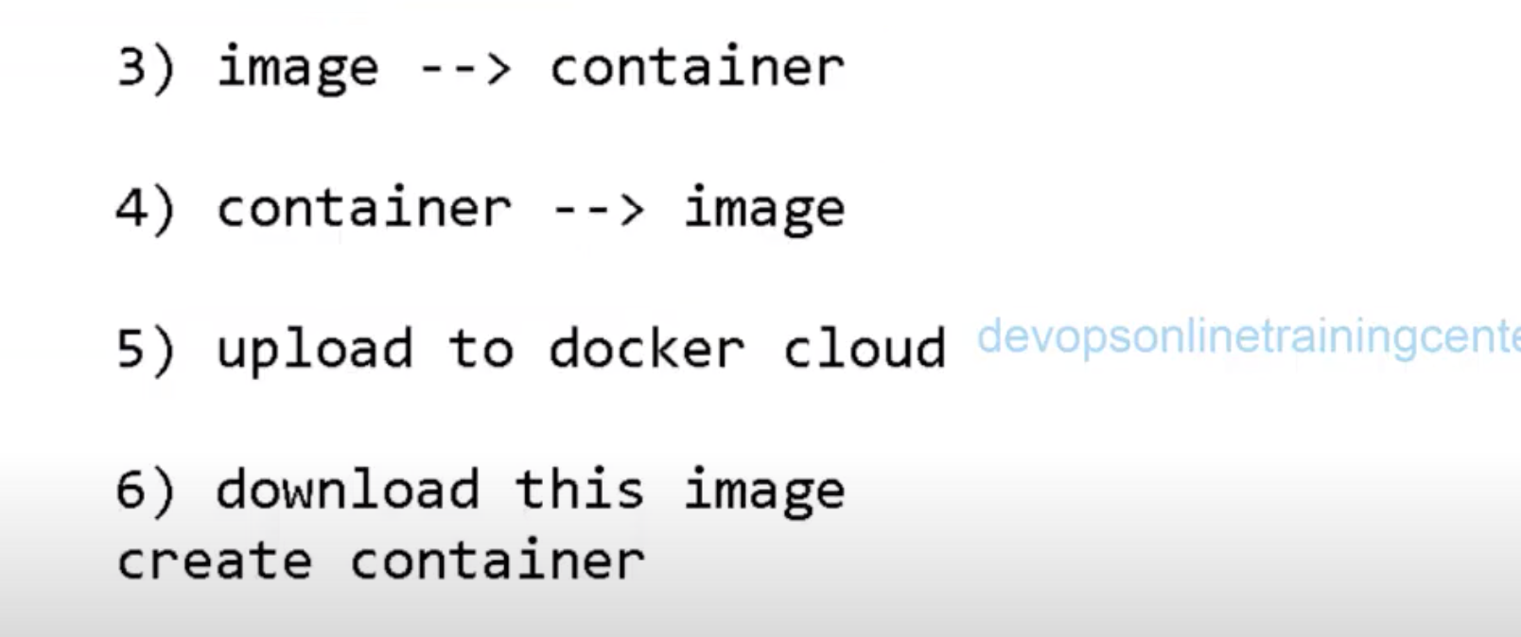

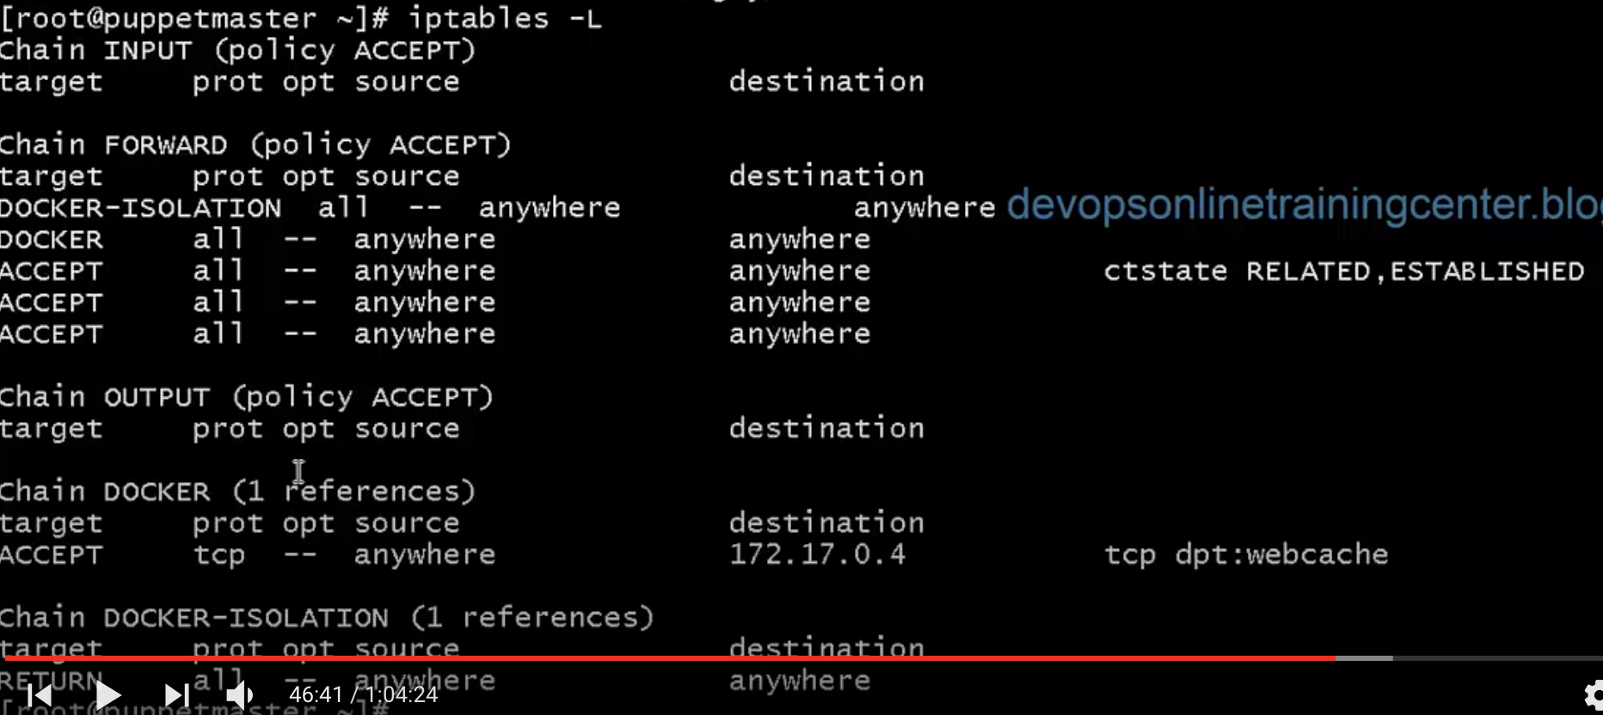

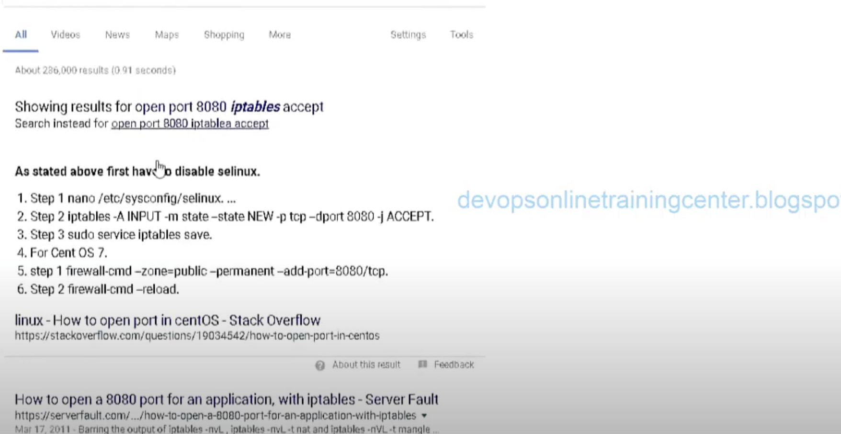

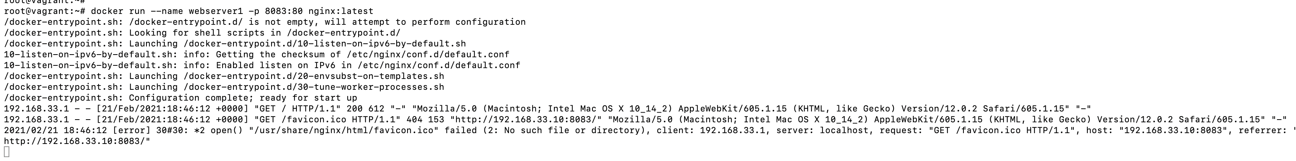

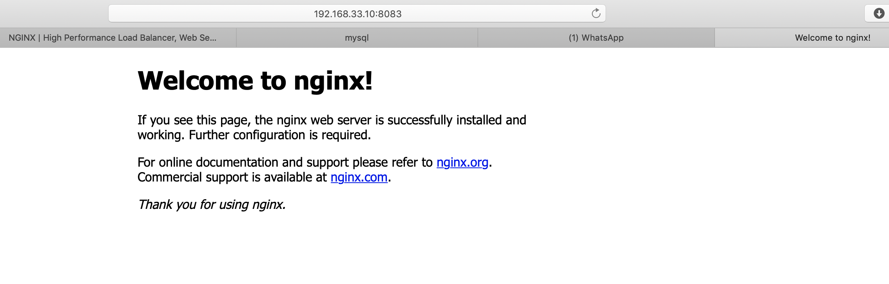

Good link-to use nginx,sql,php

<https://tech.osteel.me/posts/from-vagrant-to-docker-how-to-use-docker-for-local-web-development>

**Nginx**

But first, let's start with an extremely basic configuration to make sure everything is working properly and that we're all on the same page (this will also allow you to familiarise with a few commands in the process).

Create a folder for your project (I named mine *docker-tutorial*) and add a docker-compose.yml file into it, with this content:

nginx:

image: nginx:latest

ports:

- 80:80

Save it and, from that same folder in your terminal, run:

$ docker-compose up -d

It might take a little while as the Nginx image needs to be pulled first. When it is done, run:

$ docker-machine ip default

Copy the IP address that displays and paste it in the address bar of your favourite browser. You should see Nginx's welcome page:

Saltstack:--

